**MODULE 2(CSS and CSS 3)**

**Q=:-** **What are the benefits of using CSS?**

Ans:-Benefit of Css:

Ex:-1.Faster Page Speed

2.Easy Formatting Changes.

3.Easy Web Layout Changes

**Q=:-** **What are the disadvantages of CSS?**

Ans:-The Disadvantages of CSS is Confusion due to many CSS level.and Cross-Browser issu and Security issue.

**Q=:- What is the difference between CSS2 and CSS3?**

Ans:-The Difference of The CSS3 version supports more browsers than CSS2.

The CSS2 only web safe fonts can be used.and CSS3 with special font can be used such as those in google font.

CSS2 Doesn’t support the Border-Box property. CSS3 Support the Border-Box Property.

**Q=:-** **Name a few CSS style components.**

Ans:- The elements of style are as follows

=>Font-size,width,height,background-color,color,float,text-align,font-family etc.

**Q=:-** **What do you understand by CSS opacity?**

Ans:- The opacity property sets the opacity of an element. Opacity is the degree to which the content element is hidden, and is the opposite of transparency.  The opacity-level describes the transparency-level, where 1 is not transparent at all, 0.5 is 50%.

**Q=:- How can the background color of an element be changed?**

Ans:- To add background color in HTML, use the CSS background-color property. Set it to the color name or code you want and place it inside a style attribute.

Ex:-body

{

Background-color:red;

}

**Q=:-** **How can image repetition of the backup be controlled?**

Ans:- You can use no-repeat value for the background-repeat property if you do not want to repeat an image, in this case, the image will display only once.

Ex:-

.body

{

    background-image: url(image path);

    background-repeat: no-repeat;

}

**Q=:-** **What is the use of the background-position property?**

Ans:- The background-position property sets the starting position of a background image. Tip: By default, a background-image is placed at the top-left corner of an element, and repeated both vertically and horizontally.

Ex:-

.form

{

    background-position: left;

}

**Q=:-Why should background and color be used as separate properties?**

Ans:- There are two reasons behind this: It enhances the legibility of style sheets. The background property is a complex property in CSS, and if it is combined with color, the complexity will further increase.

**Q=:-How to center block elements using CSS1?**

Ans:- To centrally align the block elements, we can simply make use of the <center> tag. All the elements within the <center> tag will be centrally aligned.

Ex:-

  <center>

    <form>

        <!-- first_name -->

        <label for="">First Name:</label><br>

        <input type="text" placeholder="Enter your first name"><br>

        <label for="">Last Name:</label><br>

        <input type="text" placeholder="Enter your last name"><br>

        <!-- email -->

        <label for="">Email:</label><br>

        <input type="email" placeholder="it should contain @.."><br>

        <!-- mobile number -->

        <label for="">Mobile:</label><br>

        <input type="tel" placeholder="only 10 digits are allowed" minlength="10" maxlength="10"><br>

    </center>

**Q=:-What are the ways to integrate CSS as a web page?**

Ans:- CSS may be added to HTML in three different ways.

1.Inline CSS

Ex:-  <header style="color: aqua;">

        <header class="side_logo"></header>

    </header>

2.Internal CSS

Ex:-     <style>

        header

        {

            background-color: yellow;

        }

    </style>

</head>

<body>

    <header>

        <header class="side_logo"></header>

    </header>

</body>

</html>

3.External CSS

Ex:- <head>

    <meta charset="UTF-8">

    <meta http-equiv="X-UA-Compatible" content="IE=edge">

    <meta name="viewport" content="width=device-width, initial-scale=1.0">

    <title>Global_Market</title>

    <link rel="stylesheet" href="style.css">

    <link rel="stylesheet" href="https://cdnjs.cloudflare.com/ajax/libs/font-awesome/6.4.0/css/all.min.css">

</head>

<body>

    <header>

        <header class="side_logo"></header>

    </header>

</body>

</html>

/* =============Service========== */

.submenu_ca

{

    width: 84%;

    margin-left: 13%;

    height: 50px;

    /* background-color: violet; */

}

**Q=:-What is embedded style sheets?**

Ans:- An embedded style sheet is declared within the <head> element of an XHTML document.

Ex:-  <embed src="imagepath" type="">

**Q=:-What are the external style sheets?**

Ans:- An external style sheet is a separate CSS file that can be accessed by creating a link within the head section of the webpage.

Ex:-    <title>Student_Register_form</title>

    <link rel="stylesheet" href="styl.css">

</head>

<body>

    <h1>Student Registration Form</h1>

    <form>

        <!-- first_name -->

        <label for="">First Name:</label><br>

        <input type="text" placeholder="Enter your first name"><br>

        <label for="">Last Name:</label><br>

        <input type="text" placeholder="Enter your last name"><br>

        <!-- email -->

</form>

</body>

**Q=:-What are the advantages and disadvantages of using external style sheets?**

Ans:-Advantages of css

=> one change to the style sheet will change all linked pages.

=>you can create classes of styles that can then be used on many different HTML elements.

=>consistent look and feel across multiple web pages.

Disadvantages of Css

=>Your pages may not be rendered correctly until the external CSS is loaded.

=>Uploading or linking to multiple CSS files can increase your site's download time.

**Q=:-What is the meaning of the CSS selector?**

Ans:- It is a pattern of elements and other terms that tell the browser which HTML elements should be selected to have the CSS property values inside the rule applied to them.

Ex:-cllas ,Id,*,>

**Q=:-What are the media types allowed by CSS?**

Ans:- continuous or paged.

visual, audio, speech, or tactile.

grid (for character grid devices), or bitmap.

Ex:- Mobile devices 320px — 480px

iPads, Tablets :-481px — 768px

Small screens, laptops :-769px — 1024px:

Desktops, large screens:-  1025px — 1200px:

**Q=:-What is the rule set?**

Ans:- A table of instructions used by a controlled interface to determine what data is allowable and how the data is handled between interconnected systems.

**Q=:-Create Layouts**

Ans:- 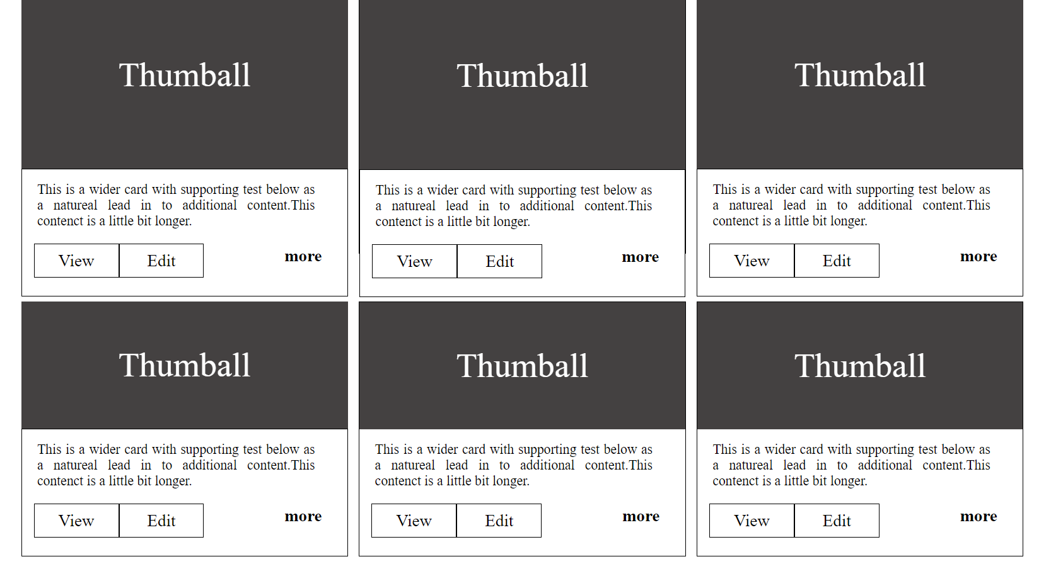

**Code:-**

<!DOCTYPE html>

<html lang="en">

<head>

    <meta charset="UTF-8">

    <meta http-equiv="X-UA-Compatible" content="IE=edge">

    <meta name="viewport" content="width=device-width, initial-scale=1.0">

    <title>Thumball</title>

    <style>

        *

        {

            margin: 0%;

            padding: 0%;

            box-sizing: border-box;

        }

        .main

        {

            width: 100%;

            height: 600px;

            /* background-color: yellowgreen; */

        }

        .main_first

        {

            width: 90%;

            height: 300px;

            margin-left: 5%;

            /* background-color: aquamarine; */

            float: left;

            margin-top: 2%;

            display: flex;

        }

        .main_first .first

        {

            width: 30%;

            height: 50px;

            /* background-color: red; */

        }

        .first_thumb

        {

            width: 100%;

            height: 250px;

            /* background-color: yellow; */

        }

        .one

        {

            width: 90%;

            height: 350px;

            float: left;

            margin-left: 4%;

            margin-top: 6px;

            margin-right: 3%;

            /* background-color: wheat; */

            display: flex;

        }

        .one_thumb_one

        {

            width: 30%;

            height: 350px;

            /* background-color: turquoise; */

            margin-left: 3%;

        }

        .thumb_1

        {

            width: 100%;

            height: 200px;

            color: white;

            background-color: rgb(68, 65, 65);

            text-align: center;

            font-size: 40px;

            line-height: 180px;

        }

        .thumb_2

        {

            width: 100%;

            height: 150px;

            background-color: white;

            border: 1px solid black;

        }

        .thumb_2 p

        {

            text-align: justify;

            width: 90%;

            padding-top: 15px;

            padding-left: 18px;

        }

        .thumb_2 b

        {

            font-size: 20px;

            float: right;

            margin-right: 30px;

            margin-top: 20px;

        }

        .two_thumb_two

        {

            width: 30%;

            height: 300px;

            background-color: white;

            margin-left: 1%;

            border: 1px solid black;

        }

        .two_thumb_two p

        {

            text-align: justify;

            width: 90%;

            padding-top: 15px;

            padding-left: 18px;

        }

        .two_thumb_two b

        {

            font-size: 20px;

            float: right;

            margin-right: 30px;

            margin-top: 20px;

        }

        .three_thumb_three

        {

            width: 30%;

            height: 350px;

            /* background-color:blue; */

            margin-left: 1%;

        }

        .view

        {

            width: 100px;

            height: 40px;

            font-size: 20px;

            margin-left: 14px;

            text-align: center;

            line-height: 40px;

            margin-top: 17px;

            background-color: white;

            border: 1px solid black;

            float: left;

        }

        .Edit

        {

            width: 100px;

            height: 40px;

            font-size: 20px;

            border: 1px solid black;

            /* margin-left: 10px; */

            text-align: center;

            line-height: 40px;

            float: left;

            margin-top: 17px;

            background-color: white;

        }

        .two

        {

            width: 90%;

            height: 250px;

            float: left;

            margin-left: 4%;

            margin-top: 6px;

            margin-right: 3%;

            /* background-color: wheat; */

            display: flex;

        }

        .one_thumb_two

        {

            width: 30%;

            height: 200px;

            /* background-color: white; */

            margin-left: 3%;

        }

        .thumb_one

        {

            width: 100%;

            height: 150px;

            background-color: rgb(68, 65, 65);

            text-align: center;

            color: white;

            font-size: 40px;

            line-height: 150px;

        }

    </style>

</head>

<body>

    <div class="main">

        <div class="one">

            <div class="one_thumb_one">

                <div class="thumb_1">Thumball</div>

                <div class="thumb_2">

                    <p>This is a wider card with supporting test below as a natureal lead in to additional content.This contenct is a little bit longer.</p>

                    <div class="view">View</div>

                    <div class="Edit">Edit</div>

                    <b>more</b>

                </div>

            </div>

            <!-- three_thumb_two -->

            <div class="two_thumb_two">

                <div class="thumb_1">Thumball</div>

                <div class="thumb_2">

                    <p>This is a wider card with supporting test below as a natureal lead in to additional content.This contenct is a little bit longer.</p>

                    <div class="view">View</div>

                    <div class="Edit">Edit</div>

                    <b>more</b>

                </div>

            </div>

                <!-- three_thumb_three -->

            <div class="three_thumb_three">

                <div class="thumb_1">Thumball</div>

                <div class="thumb_2">

                    <p>This is a wider card with supporting test below as a natureal lead in to additional content.This contenct is a little bit longer.</p>

                    <div class="view">View</div>

                    <div class="Edit">Edit</div>

                    <b>more</b>

                </div>

            </div>

        </div>

        <!-- two -->

        <div class="two">

            <div class="one_thumb_two">

                <div class="thumb_one">Thumball</div>

                <div class="thumb_2">

                    <p>This is a wider card with supporting test below as a natureal lead in to additional content.This contenct is a little bit longer.</p>

                    <div class="view">View</div>

                    <div class="Edit">Edit</div>

                    <b>more</b>

                </div>

            </div>

            <div class="two_thumb_two">

                <div class="thumb_one">Thumball</div>

                <div class="thumb_two_1">

                    <p>This is a wider card with supporting test below as a natureal lead in to additional content.This contenct is a little bit longer.</p>

                    <div class="view">View</div>

                    <div class="Edit">Edit</div>

                    <b>more</b>

                </div>

            </div>

            <!-- two_thumb_two -->

            <div class="two_thumb_two">

                <div class="thumb_one">Thumball</div>

                <div class="thumb_two_1">

                    <p>This is a wider card with supporting test below as a natureal lead in to additional content.This contenct is a little bit longer.</p>

                    <div class="view">View</div>

                    <div class="Edit">Edit</div>

                    <b>more</b>

                </div>

            </div>

        </div>

    </div>

</body>

</html>